**UNIT 1**

**INTRODUCTION TO ROCKET PROPULSION**

A rocket is a vehicle which works on the principle of Newton's third law which states that "for every action there is an equal and opposite reaction". A rocket is a sophisticated jet powered vehicle intended to carry equipments or crew beyond earth and into the space to perform a specific application or purpose

Space is generally defined as starting at about 100km (60 miles) above Earth (an arbitrary point sometimes called the Karman line), which is where conventional planes would struggle to make enough lift to stay in the air. Space is the place effectively beyond Earth's reach, beyond most of its gravity and atmosphere.

A rocket engine in its simplest form consists of a propellant system, combustion chamber and a nozzle. Here the fuel and the oxidant are thoroughly mixed in the combustion chamber which when ignited results in large volume of exhaust gases that passes through the nozzle, thus creating thrust. The force responsible for pushing or propelling the vehicle forward is called as the Thrust of the engine. Common applications of rockets are Fireworks, Weaponry, Aircraft seat ejection systems, Satellites for space exploration, planetary and interplanetary missions.

**DIFFERENCES BETWEEN AIR BREATHING AND NON AIR BREATHING ENGINES**

|  |  |  |
| --- | --- | --- |
|  | **AIR BREATHING** | **NON- AIR BREATHING** |
| 1 | Uses Atmospheric air for combustion | Carries its own Oxygen for combustion |
| 2 | Cannot operate in vacuum | Can operate in vacuum |
| 3 | Altitude is limited | No limit for altitude |
| 4 | Operation and performance depends on altitude | Operation and performance will not depend on altitude |
| 5 | Thrust decreases with altitude | Thrust increases slightly with altitude |
| 6 | Rate of climb decreases with altitude | Rate of climb increases |
| 7 | Ram effect increases with flight speed | Unaffected by Ram effect |
| 8 | Very Low T/W ratio 7:1 | Very high T/W ratio around 100:1 |
| 9 | Low Specific fuel consumption 0.05-0.15 kg/hr-N | High Specific fuel consumption 0.8-1.428 kg/hr-N |
| 10 | Very high specific impulse 2000 seconds | Very low specific impulse 300-400 seconds |
| 11 | Reasonable efficiency | Low efficiency |

**TYPES OF PROPULSION SYSTEMS BASED ON THE SOURCE OF ENERGY**

1. Solid Propellant Rockets
2. Liquid Propellant Rockets
3. Gaseous Propellant Rockets
4. Hybrid Propellant Rockets
5. Nuclear Propellant Rockets
6. Electric Propellant Rockets
7. Solar Propellant Rockets

**SOLID PROPELLANT ROCKETS**

The technology of solid rocket propulsion is well understood and disseminated that many companies or government arsenals are now capable of designing developing, and manufacturing solid rockets in several categories. Solid propellant rocket motors are being built in approximately 35 different countries today, compared to only three countries about 50 years ago.

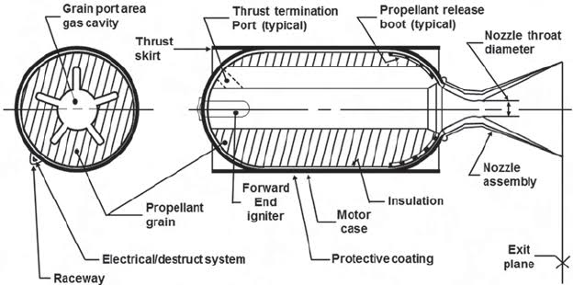

***Fig : Solid Propellant Rocket***

A category of rockets which use propellants in solid form or solid state are known as solid propellant rockets and solid propellant rockets are usually termed as Motors. In solid propellant rockets, the propellants namely, the fuel and the oxidizer which are in the solid form are thoroughly grinded and reduced to fine granules. The solid propellant charge in the form of fine granules are called as Grains and it contains all the chemical elements for complete burning. In solid propellant rocket motors, the grains are thoroughly packed and stored in the combustion chamber and sometimes hermetically sealed in the chamber for long-time storage upto 20 years. The hardened solid grains stored in the combustion chamber case typically accounts for 90% of the total motor mass. A cylindrical star shaped cavity is provided for combustion in the centre along the axis of the shell. Different shapes and geometric features like slots, grooves, holes etc can be provided in the cavities so that various burning time profiles can be obtained which alters the thrust profile suitable for a given mission. The inner surfaces of the case (really a pressure vessel), which are exposed directly to hot gas, have a thermal protection or insulation layer to keep the case from becoming too hot, in which case it could no longer carry its pressure and other loads. The case is either made of metal (such as steel, aluminium or titanium) or a composite fiber-reinforced plastic material. An electrically activated igniter located at the top provides the energy to start the combustion process. Initial burning takes place at the internal surfaces of the cylindrical perforation of the propellant.

Once ignited, it usually burns smoothly at a predetermined rate on all the exposed internal surfaces of the grain. The motor combustion proceeds in an orderly manner until essentially all the propellant has been consumed. The energy from a high-pressure combustion reaction of propellant chemicals, permits the heating of reaction product gases to very high temperatures (2500 to 4100°C).The hot reaction gases flow along the perforation or port cavity toward the nozzle. These gases subsequently are expanded and accelerated to very high velocities (1800 to 4300 m/sec) through supersonic nozzle. The nozzle is usually made of high temperature materials (usually a graphite and/or an ablative material to absorb the heat) to withstand the high temperatures and the erosion. The majority of all solid rockets have a simple fixed nozzle, as shown here, but some nozzles have provision to rotate it slightly so as to control the direction of the thrust to allow vehicle steering. Motors come in many different types and sizes, varying in thrust from about 2 N to over 4 million N). The solid motor is used mainly as a booster for launch vehicles. Solid motors are almost never used in space because they are not controllable. The boosters are lit and then they fire until all the propellant has burned. Their main benefits are simplicity, a shelf life which can extend to years as in the case of missiles, and high reliability.

**ADVANTAGES**

1. In comparison to liquid rockets, solid rockets are usually relatively simple, are easy to apply (they often constitute most of the vehicle structure), and
2. Higher thrust at relatively low cost
3. Free from moving parts- no feed systems or valves
4. Comparatively lighter for shorter range and small size
5. On account of high density much larger quantity of propellant can be packed into a small space.
6. Specific gravity is as high as 2
7. Requires Less servicing
8. Vibrations arising from turbo-pump and liquid flow are absent
9. Problems arising from sudden emptying of propellant tanks are absent

**DISADVANTAGES**

1. Specific impulse is comparatively lower than Liquid Rockets
2. Exhaust velocities are less, so less performance
3. Impossible to turn-off the motor midway, once started engine cannot be stopped
4. Minor malfunctioning or accident will abort the whole mission
5. Difficult to control combustion and regulate thrust
6. Not re-usable
7. Only for small size and short range rockets
8. Long range rockets are very heavy
9. Transporting and handling is very difficult
10. Refuelling not possible
11. Nozzle suffers from erosion of grain particles

**PROPERTIES OF SOLID PROPELLANTS**

1. Propellant materials should be abundantly available
2. It should be easy and safe to handle the propellants
3. It should be easy and safe to grind, mix, heat, trim, pack and store the propellants. Also it should be practical to cast or extrude the solid propellants in desired shapes and sizes.
4. Physical and chemical properties of the propellant mixture should not change considerably during processing
5. Heat of chemical reaction between the fuel and oxidizer should be very high so that the high combustion temperatures and specific impulse are obtained.
6. Properties of the solid propellants should not deteriorate with time.
7. They should be chemically inert before ignition and should not ignite with slight impact, shock or pressure.
8. They should possess high mechanical strength.
9. They must have comparatively lower molecular weight and higher density which yields high values of specific impulse and also result in lighter structure.
10. In case of military applications, the exhaust gases should be smokeless and colourless.
11. They should not be hygroscopic i.e., they should not react with atmospheric air and moisture.
12. There should not be any chemical reaction between the constituents of the propellant materials while in storage.

**LIQUID PROPELLANT ROCKETS**

A rocket which uses liquid propellants, i.e., liquid fuel and liquid oxidizer for propulsion is called as Liquid propellant rocket. A liquid propellant rocket propulsion system is commonly called a rocket engine. It has all the hardware components and propellants necessary for the task of producing the required thrust. The most important part of any liquid propellant rocket is the thrust chamber because it provides an housing for major components like the combustion chamber itself, propellant tanks, feed mechanisms, fuel injectors and other control devices to initiate and regulate the propellant flow.

In liquid propellant rockets, the liquid fuel and liquid oxidizer will be stored in separate tanks at a very high pressure. During the working of any typical liquid propulsion rockets, the liquid propellants are introduced into the thrust chamber at very high pressure. Usually the propellants are introduced using either the pump fed systems or pressure fed system depending on the configuration of the engine. For better mixing and efficient combustion, the liquid propellants are metered, injected, atomized and mixed thoroughly by passing through the fuel injectors. After through mixing is achieved, the fuel-oxidizer charge is ignited electrically using igniters which results in combustion of propellants. The energy from a high-pressure combustion reaction of propellant chemicals, a fuel and an oxidizing chemical, permits the heating of reaction product gases to very high temperatures (2500 to 4100°C). These gases subsequently are expanded in a supersonic nozzle and accelerated to high velocities (1800 to 4300 m/sec) imparting a huge thrust. Since these gas temperatures are about twice the melting point of steel, it is necessary to cool or insulate all the surfaces that are exposed to the hot gases. In a cooled thrust chamber, one of the propellants (usually the fuel) is circulated through cooling jackets or a special cooling passage to absorb the heat that is transferred from the hot reaction gases to the thrust chamber walls (see Figs 8-2 and 8-3). A radiation- cooled thrust chamber uses a special high-temperature material, such as niobium metal, which can radiate away its excess heat. There are uncooled or heat-absorbing thrust chambers, such as those using ablative materials.

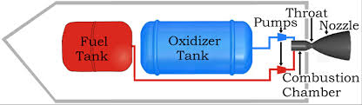

***Fig : Liquid Propellant Rocket Engine***

Liquid propellants can be broken into three main types: monopropellant, bipropellant, and cryogenic thrusters. Monopropellants only use one propellant such as hydrazine. Bipropellants use a fuel and an oxidizer such as RP-1 and H2O2. Cryogenic systems use liquefied gases such as LiH and LOX (liquid hydrogen and liquid oxygen). Cryogenic means super-cooled, wherein the propellants are stored at very super cooled temperatures to make them liquids. With each step from monopropellant to bipropellant to cryogenic the thrusters complexity goes up but the performance also goes up.

**ADVANTAGES**

1. Liquid Propellant engines can be reused after recovery. This offers considerable economic benefits.
2. They offer more flexibility and greater control over the thrust. The operation is more stable.
3. The propellants are not stored in the thrust chamber. Therefore, aerodynamically and structurally better and safer thrust chambers can be designed.
4. Higher values of specific impulse.
5. Wreckage on account of some defect or malfunctioning is not sudden allowing time for corrective measure and safety action. This offers greater safety to the crew.
6. It is much easier to stop the operation in case of an impending catastrophe.
7. Regenerative heating of the propellant before combustion along with the cooling of the nozzle and the thrust chamber is possible. This offers thermodynamic and structural advantages.
8. It is much easier to run an auxiliary power plant.
9. More economical for long range space and military operations.

**DISADVANTAGES**

1. More complicated compared to solid rockets. There is greater probability of problems arising on account of malfunctioning of turbo-pump systems, valves, leakage, vibrations etc.
2. Many liquid propellant are cryogenic which require special arrangements for heat insulation, solar radiation shields and handling at low temperatures.
3. There are additional handling and safety problems if the propellants are poisonous and hazardous.
4. They require propellant feed pumping systems or tank pressurization increasing the total weight of the rocket.
5. On account of lower density of the liquid propellants compared to solid propellants, large storage space is required thus increasing the size and weight of the engine.
6. It takes much longer time to design, manufacture and test liquid propellant rockets. They cannot be mass produced in a short time for military applications.

**APPLICATIONS OF LIQUID PROPELLANT ROCKETS**

1. Mostly used for primary propulsion engines
2. Used in lower stages of most of the rockets
3. Upper stages of missiles
4. In deep space rockets

**Properties of Liquid Propellants**

1. Energy released during combustion per unit mass of the propellant combination should be high.
2. High density propellants are preferred; they require smaller tanks and structures offering lower values of the mass ratio and aerodynamic drag.
3. The propellants should have lower freezing point; this makes the handling of propellants, particularly cryogenic propellants easier in various rocket components. Low freezing point rules out any possibility of freezing of the propellants at high altitudes and in cold weather.
4. They must be non-corrosive so that their handling is easier and less demanding on materials used in various parts of the rocket.
5. They should be chemically stable Their properties should not deteriorate with time. They should not absorb moisture. Small amounts of impurities should not change their chemical properties.
6. Propellants should have low values of vapor pressure and viscos­ity. Lower vapor pressure avoids Cavitation problems in lire feed pumping system. Lower viscosity decreases the power required for pumping.
7. Propellants must have higher specific heat and thermal conductiv­ity for better performance.
8. They should not be poisonous and hazardous. Some propellants are poisonous; they are dangerous for personnel if inhaled and touched. Others ignite easily when they come in contact with air. Such propellants may explode if not carefully stored and handled. Handling, transportation and storage should he simple, convenient and safe.
9. Propellants chosen should be cheap and abundantly available. The raw materials required for their large scale manufacture should be easily available. The manufacturing process required for producing propellants should be simple and inexpensive.
10. Products of combustion must have lower values of the molecular weight and gas constant.

**HYBRID PROPELLANT ROCKET**

Hybrid propellant rocket propulsion systems use both liquid and a solid propellants to create a propulsive force (thrust). This type of rocket propulsion system combines the advantages of both solid and liquid propellant rockets systems. Such kind of rockets either use liquid fuel-solid oxidizer or liquid oxidizer-solid fuel combination. Various combinations of solid fuels and liquid oxidizers as well as liquid fuels and solid oxidizers have been experimentally evaluated for use in hybrid rocket motors. Most common is the liquid oxidizer-solid fuel combination because of its advantages over liquid fuel-solid oxidizer combination. Here the solid fuel grains are completely packed into the combustion chamber and the liquid oxygen will be stored at high pressures. During working the high pressure liquid oxidiser will be introduced into the central region of the solid fuel and a chemical reaction will be induced between them. For some combination of fuel-oxygen mixture, ignition has to be provided by means of igniter plugs but there are some combination for which ignition is not necessary. Just a mere contact between the fuel and oxidizer will be sufficient to promote combustion. Such kind of propellants are known as hypergolic propellants. Rockets with hypergolic propellants are easy to fire and reaction can be started or stopped when required.

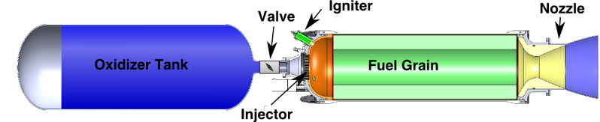

***Fig : Hybrid Propellant rocket***

The advantages of Hybrid propellant rockets are

1. Thrust control is easier just by controlling the amount of liquid oxygen regulated
2. Start-stop-restart capabilities;
3. Since the fuel and oxidiser are stored separately there won't be any chemical deterioration which occurs in Solid PR
4. Due to the absence of turbo pump feed system, the Hybrid PR are lighter in construction
5. Various fuel grain combination can be considered
6. In case of accident the explosion is less compared to LPR
7. Relatively low system cost
8. Higher specific impulse than solid rocket motors and higher density-specific impulse than liquid bipropellant engines;
9. The ability to smoothly change motor thrust over a wide range on demand.

The disadvantages of hybrid rocket propulsion systems are:

1. Mixture ratio and, hence, specific impulse will vary somewhat during steady-state operation and throttling
2. Lower density-specific impulse than solid propellant systems
3. Some fuel sliver must be retained in the combustion chamber at end-of burn, which slightly reduces motor mass fraction
4. Unproven propulsion system feasibility at large scale.

**APPLICATIONS**

Hybrid propulsion is well suited to applications or missions requiring throttling, command shutdown and restart, long-duration missions requiring storable nontoxic propellants, or infrastructure operations (manufacturing and launch) that would benefit from a non-self-deflagrating propulsion system.

They are primarily used for

1. Primary boost propulsion for space launch vehicles,
2. High-energy upper-stage motors
3. Satellite manoeuvring systems
4. Target missiles and low-cost tactical missile applications

**NUCLEAR PROPELLANT ROCKETS**

Nuclear energy is always associated with the transformation of atomic particles within the nucleus of atoms and these atomic transformations are always associated with the liberation of enormous amounts of heat energy. In Nuclear propellant rockets, this liberated heat energy is utilized to heat to a working fluid, usually liquid hydrogen, which subsequently can be expanded in a nozzle and thus accelerated to high ejection velocities (6000 to 10,000 m/sec).

Three different types of nuclear energy sources have been investigated to be employed for rocket propulsion. They are Nuclear Fission, Radioactive Isotope source decay and Nuclear Fusion processes. A number of different concepts have been studied. To date none have been tested and many concepts are not yet feasible or practical. Concerns about an accident with the inadvertent spreading of radioactive materials in the earth environment and the high cost of development programs have to date prevented a renewed experimental development of a large nuclear rocket engine. Unless there are some new findings and a change in world attitude, it is unlikely that a nuclear rocket engine will be developed or flown in the next few decades.

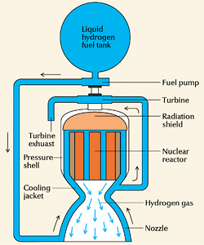

***Fig : Working of a nuclear rocket engine***

**NUCLEAR FISSION ROCKETS**

In the nuclear fission reactor rocket, heat can be generated by the fission of uranium in the solid reactor material and subsequently transferred to the working fluid. The nuclear fission rocket is primarily a high-thrust engine (above 40,000 N) with specific impulse values up to 900 sec. Fission rockets were designed and tested in the 1960s. Ground tests with hydrogen as a working fluid culminated in a thrust of 980,000 N at a graphite core nuclear reactor level of 4100 MW with an equivalent altitude-specific impulse of 848 sec and a hydrogen temperature of about 2500 K. There were concerns with the endurance of the materials at the high temperature(above 2600 K) and intense radiations, power level control, cooling a reactor after operation, moderating the high energy neutrons, and designing lightweight radiation shields for a manned space vehicle. In recent years there have been renewed interest in nuclear fission rocket propulsion primarily for a potential manned planetary exploration mission. Studies have shown that the high specific impulse (estimated in some studies at 1100 sec) allows shorter interplanetary trip transfer times, smaller vehicles, and more flexibility in the launch time when planets are not in their optimum relative position.

**ELECTRIC PROPELLANT ROCKETS**

Electric propulsion has been considered for space applications since the inception of the space program in the 1950s but has only begun to make widespread impact since the mid-1990s. This is a result of the availability of sufficiently large amounts of electrical power in spacecraft.

Electric propellant rockets are a category of rockets which use electrical energy to heat and accelerate the propellants. The source of electrical energy in electric propulsion rockets, is usually generated using either nuclear energy, solar energy or energy stored in batteries. In all electric propulsion rockets, the source of the electric power is independent of the propellant itself. The basic subsystems of a typical electric propulsion thruster are:

* A raw energy source such as solar or nuclear energy with its auxiliaries such as concentrators, heat conductors, pumps, panels, radiators, and controls
* Conversion devices to transform this energy into electrical form at the proper voltage, frequency, pulse rate, and current suitable for the electrical propulsion system
* A propellant system for storing, metering, and delivering the propellant and
* One or more thrusters to convert the electric energy into kinetic energy of the exhaust.

Electric propulsion rockets can be distinguished into three fundamental types:

**Types of Electric Propulsion Rockets**

**Electrothermal Thrusters-** These are the type of rockets in which the thrust produced is purely based on the principle of thermodynamics. Since the thrust produced by the electrical rockets are very less, they are usually termed as thrusters rather than rockets.

1. **Resistive method -** The simplest way is to heat the propellant with a hot wire through which electric current passes. Though this method seems very elementary it has been used is some commercial thrusters and are very successful.
2. **Electric Arc Method** - In case of more energy requirements, using the electric current an electric arc can be struck and when the propellants are fed through this electric arc, the propellants are heated up and passed through a nozzles to accelerate it further to create thrust. This method generates higher temperatures and higher exhausts velocities than the resistive method.

3) **Electro-Static Rockets** – These rockets use electric and magnetic fields to produce thrust.

In this method electric or magnetic fields are used to directly accelerate the propellants to very high velocities producing the highest exhaust velocities of all. The ion thrusters and hall effect thrusters comes under this category and are seen as the most promising for deep space missions, interplanetary missions and station keeping missions.

**Electro thermal Rockets-Resistojet Rockets**

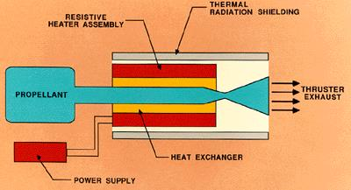

***Schematic of a Resistojet Thruster***

Electro-thermal rockets use both electrical energy and thermal energy or specifically, the principles of thermodynamics to heat up the propellant and expand the exhaust gas in a suitable nozzle to create thrust.

In this case, the rocket consists of a wire or a filament that heats up due to resistive heating and the heat that is generated is used for generating thrust and hence the name Resistojet. The same principle happens in household geysers or industrial geysers which are used to heat the water.

The basic Resistojet Rocket consist of **propellant storage tank** (ammonium, hydrogen, nitrogen, or hydrazine decomposition product gases have been used as propellants), **heating chamber** consisting of **heating coils made up of tungsten or platinum**, **heat exchanger and heat shields**, **Power supply and a nozzle with high expansion ratio connected to the heating chamber.**

During working, the heater coil or the heater assembly will first be heated though the supplies of electric current from the on-board power supply system. The current supplied and hence the maximum gas temperature achieved in the heating chamber should always be less than the maximum serviceable temperature of the filament. Then as the high pressure gas from the propellant tank is made to pass through the heating chamber, the gas molecules will get heated up and gets converted into high temperature high pressure exhaust gases that will be expelled through the nozzle. So using lower molecular weight propellants will produce significant exhaust velocities.

To achieve high velocities, the pressure and temperature of the gas entering the nozzle need to be high. As the propellant is stored at high pressure, the losses in pressure are not as pronounced as the losses in temperature. Since gas is a bad conductor of heat, only a thin layer in close contact with the heater will become hot. To overcome this issue, a multichannel heat exchanger is used to enhance the heat radiation to as much as gas volume possible so that this we should make sure that there is efficient heating of the gas. Next, the heated wire invariably radiates some amount of heat to the chamber walls and in doing so rate of heat transfer to the gas will be poor that results in low temperature and pressure when the gas enters the nozzle. And when this occurs the total thrust and exhaust velocities are reduced. To prevent this, low mass radiation shields made up of concentric foils are used or in some cases active cooling techniques are used that can also help in regenerative heating as done on the chemical rocket.

The specific impulse Isp for resistojet thrusters is 150 to 700 Isp range, efficiency levels between 35% and 90%, and thrust between 5 and 5,00 mN (0.5N). The thrust produced by these electric propellant engines will be equivalent to the force created by a falling paper or feather. Since these engine operate in vacuum, even milli-newtons of thrust produced for a long time can accelerate the vehicles to a large exhaust velocities close to 5000m/s translating close to Mach 14.

**Advantages**

* Fuel load reduction
* Cost savings in launch vehicle option for lighter spacecraft
* Reduction of integration and testing costs by eliminating the use of hazardous propellants
* Low volume and power budgets

**Electric Arc Thrusters - Arcjet Thrustures**

This is another technique which uses electrical and thermal energies to propel space vehicles especially in vacuum. Arcjet thrusters consist of a centrally located cathode surrounded by an anode. The pointed cathode rod is supported in a boron nitride insulator which also holds the anode. The anode is shaped to create the gap across which the arc is struck and through which the propellant flows. The anode is further shaped as a nozzle which expands the gases to high exhaust velocities.

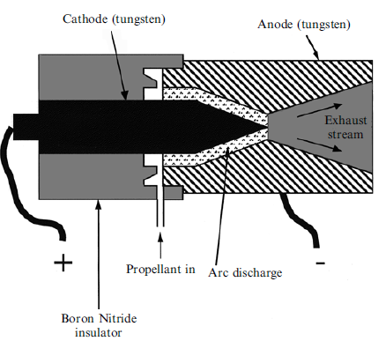

***Schematic of Arcjet Thruster***

Using the on-board electric power supply system, a steady DC potential of 200-300V high voltage electric field is struck between the cathode and anode while the propellant is injected between the two electrodes. Liquid Hydrogen (Ammonia and Hydrazine are also used), the propellant used in arcjet thrusters when passed through this high strength electric arc will be heated and result in the generation of high temperature ions. These rapidly moving ions will again recombine as they move downstream of the nozzle and when it enters the nozzle; it will be expanded to cause high velocities. In arcjet thrusters, the temperature of the propellants can be raised between 10,000 K and 20,000 K. The maximum temperature attained in arcjet thrusters is always higher compared to the resistojet thrusters where the maximum temperature is limited by the operating temperature of the wire filament. Higher temperatures in an arcjet thruster directly translate to significantly higher exhaust velocities close to 20000m/s. The indirect application of these extremely high temperatures through an electric current provides insulation for operational elements, and the expulsion pattern of the superheated gas contributes to the insulating effect. Comparatively large Isp ranges, between 280 and 2,300, give significant advantages over resistojet propulsion methods, while a comparable thrust range of 50 to 5,000 mN. However, the energy conversion efficiency of the arcjet thruster will be between 30% and 50% which is lesser than the resistojet thrusters. Additional problem with arcjet thrusters is that they are prone to electrode erosion and massive power requirements.

**Electro-Static Propellant Rockets**

In the previous section, we understood that by using Resistojet Thrusters, maximum exhaust velocities close to 5000m/s can be achieved. Then by switching to arcjet thrusters, maximum exhaust velocities can be further increased to 20km/s. But for interplanetary and interstellar space missions, the required exhaust velocities are much beyond that could be achieved using resistojet and arcjet thrusters. If we wish to exceed the exhaust velocities using electrical heating of propellants, then it is necessary to abandon thermodynamic effects and act directly upon the atoms the propellant by using pure electrostatic or electromagnetic fields. This means that the propellant has to be ionised. This is already happening in case of arcjet thrusters, but this again recombines within the nozzle to create neutral atoms that are later expanded. But the processes of ionization, recombination is a technically complicated and nuisance process. To simplify the process, the propellant needs to be ionised first and then using electric and magnetic fields the ions can be directly accelerated producing very high bulk velocities needed. Using this technique theoretical exhaust velocities close to 50000m/s can be achieved but however, practical thrusters have produced exhaust velocities beyond 30000m/s.

**Ion Propulsion**

The concept of ion propulsion is very simple as compared to the other versions of electric propulsion. Ion propulsion or ion thrusters use electro-static and electro-magnetic principles to accelerate ions to very high exhaust velocities and produce thrust. To achieve this, in an ion thruster, the ions are produced first and then accelerated to high velocities. This can be explained with the schematic below.

In ion thrusters, the process of ionization is a very important in which a neutral atom will be converted into a positively and negatively charged ions and electrons. Ionization is achieved by bombarding the propellant gas with high energy fast moving electron beam. When high energy electrons are bombarded to a neutral gas, the neutral atoms will be split into positive ions and electrons. The gas consisting of both positive ions and electrons is called as plasma and plasma is usually affected by the electric and magnetic fields.

In an ion thruster, the propellant is made to enter the ionization chamber and the propellant when it enters will in the form of neutral state. Xenon is the commonly used propellant as it has high atomic mass resulting in large ion density and gets easily ionized. The ionization chamber is facilitated with radial electric fields. Along with the propellant, the electrons from a thermionic emitter will be made to simultaneously enter the chamber. The electrons that enter the chamber will be accelerated by the radial field and reach energies of several tens of electron volt which is enough to ionise the neutral propellant atom by collisions. To increase the path length of the electrons and to ensure that they encounter as many as neutral atoms possible, an axial magnetic field is provided which makes the neutral atoms move in a spiral path. This is done to increase the number of ions produced through collisions that increases the efficiency of ionization process. This process is similar to atomization process in a traditional combustion chamber of a rocket or an aircraft. At the end of the ionization chamber two accelerator grids at a distance of 1-2mm and with thousands of precisely drilled holes are provided. Through diffusion, the positive ions are forced to move towards the first grid and they pass through it under the influence of small voltage. Later as it approaches the negative grid, a huge potential difference across the negative gird will accelerate the negative ions to very high velocities. There is no need for a nozzle to create thrust because the motions of the ions are ordered and not chaotic. Here the thermodynamic relations to calculate the thrust and performance parameter are not valid.

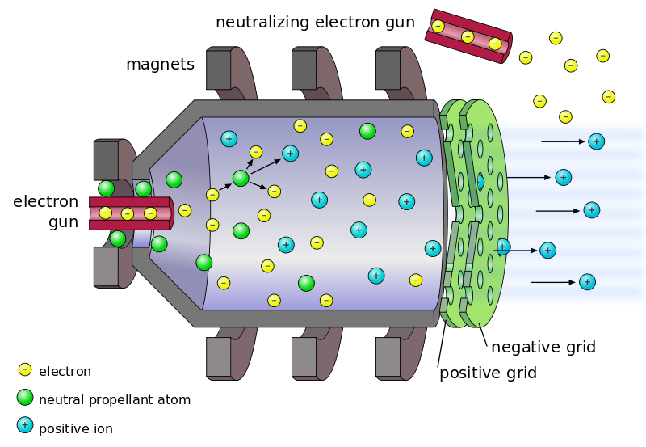

***Fig: Illustration of a typical ion propulsion system***